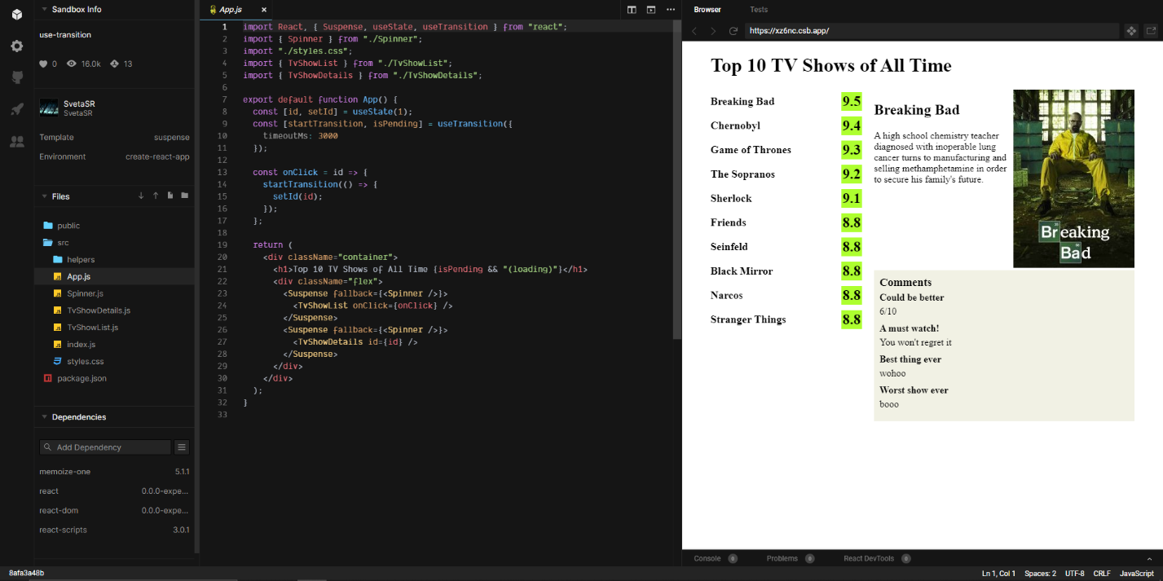  
The following source code comes from the experimental React.js Concurrency mode. There is no stable release, but it is interesting that the framework supports concurrency even if it is not in the stable release. The following code fetches information in the background while other processes are handled and displayed. I found this example and code from: <https://medium.com/swlh/what-is-react-concurrent-mode-46989b5f15da>.